Course One

Foundations of Data Science


Instructions
Use this PACE strategy document to record decisions and reflections as you work through this end-of-course project. You can use this document as a guide to consider your responses and reflections at different stages of the data analytical process. Additionally, the PACE strategy documents can be used as a resource when working on future projects.

Course Project Recap
Regardless of which track you have chosen to complete, your goals for this project are:
- Complete the PACE Strategy Document to plan your project while considering your audience members, teammates, key milestones, and overall project goal.
- Create a project proposal for the data team.

Relevant Interview Questions
Completing this end-of-course project will empower you to respond to the following interview topics:
- As a new member of a data analytics team, what steps could you take to get 'up to speed' with a current project? What steps would you take? Who would you like to meet with?
- How would you plan an analytics project?
- What steps would you take to translate a business question to an analytical solution?
- Why is actively managing data an important part of a data analytics team's responsibilities?
- What are some considerations you might need to be mindful of when reporting results?

Reference Guide
This project has three tasks; the following visual identifies how the stages of PACE are incorporated across those tasks.
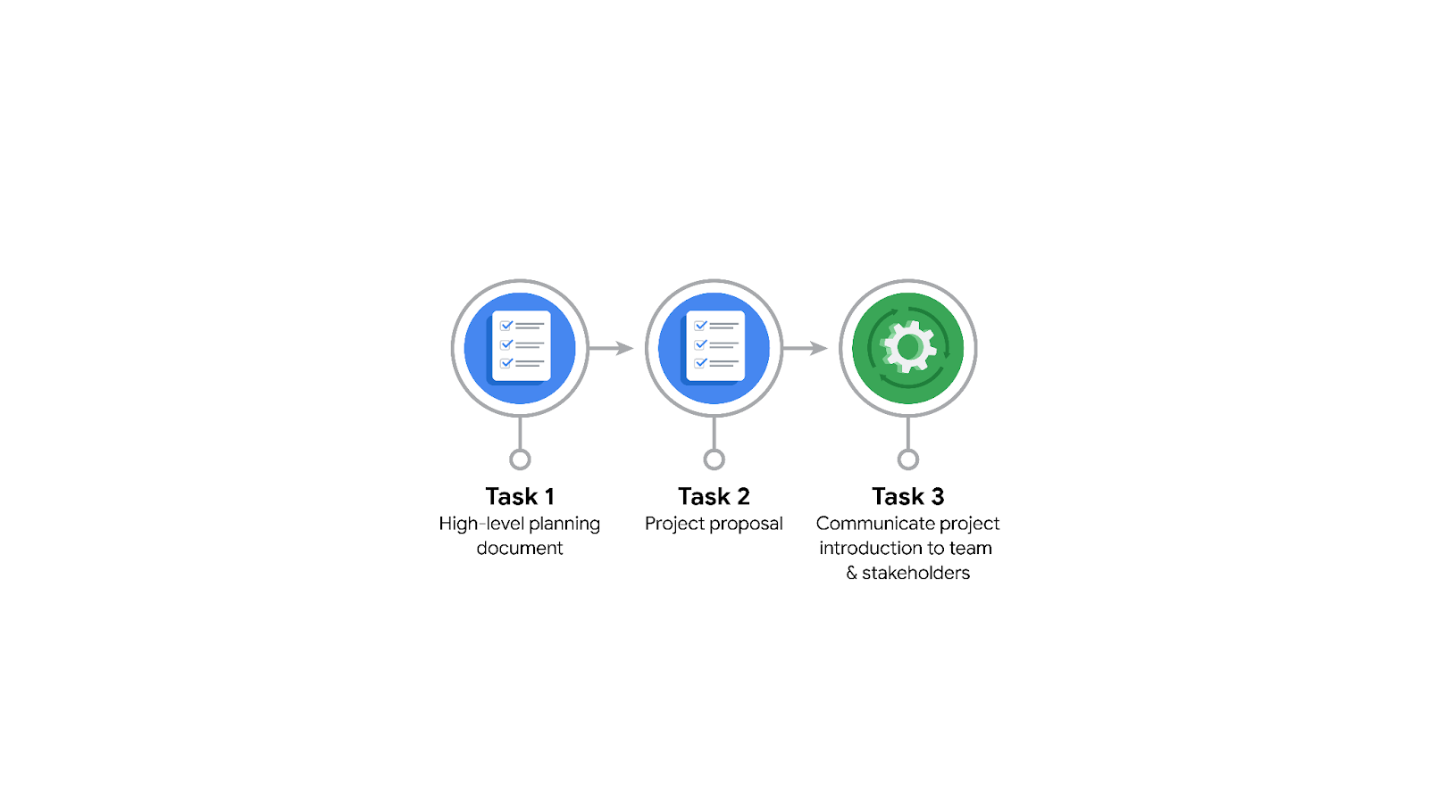

Data Project Questions & Considerations
PACE: Plan Stage

- Who is your audience for this project?
Waze’s data team and related decision-making teams

- What are you trying to solve or accomplish? And, what do you anticipate the impact of this work will be on the larger needs of the client?
Analyze and Predict users most likely to churn, their reasons to churn, and their time to churn. It will help the company to optimize users retention strategy, enhance user experience, and increase in overall growth.

- What questions need to be asked or answered?
- Identify stakeholders and communication means
- The condition of our datasets
- Trends in the dataset providing insight
- Steps to reduce bias
- Most important variables

- What resources are required to complete this project?
- Records of users over time, including: subscription, unsub. date, activities, plans, etc.
- Jupyter notebook
- Insights from stakeholders

- What are the deliverables that will need to be created over the course of this project?
- Predictive models for churn phenomena: users susceptible to, time of churn
- Identifying reasons for churn
- Visualizations
- Suggestional decisions to affect churns

THE PACE WORKFLOW
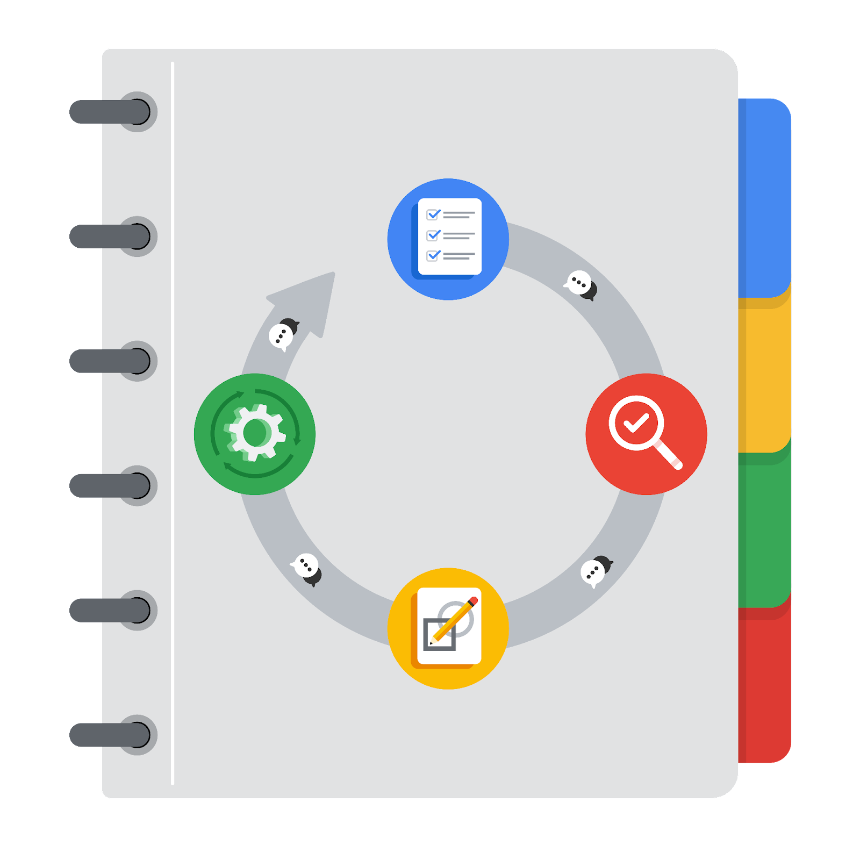
[Alt-text: The PACE Workflow with the four stages in a circle: plan, analyze, construct, and execute.]

You have been asked to demonstrate for the company's data team how you would use the PACE workflow to organize and classify tasks for the upcoming project. Select a PACE stage from the dropdown buttons. A few tasks involve more than one stage of the PACE workflow. Additionally, not every workplace scenario will require every task. Refer back to the Course 1 end-of-course portfolio project overview reading if you need more information about the tasks within the project.

Project tasks
Following are a group of tasks your company’s data team has determined need to be completed within this project. The data analysis manager has asked you to organize these tasks in preparation for the project proposal document. First, identify which stage of the PACE workflow each task would best fit under using the drop down menu. Next, give an explanation of why you selected the stage for each task. Review the following readings to help guide your selections and explanation: The PACE stages and Communicate objectives with a project proposal. You will later reorder these tasks within a project proposal.

- Evaluating the model: Construct
Why did you select this stage for this task?
It’s a part of model construction, where models must be evaluated before finalizing presentable models.

- Conduct hypothesis testing: Analyze and Construct
Why did you select these stages for this task?
Hypothesis testing over the initial data, provides a better understanding of relations and distribution of certain values.
It is also needed to be conducted in the construction stage to make sure if the mode is statistically fitting the data.

- Begin exploring the data: Analyze
Why did you select this stage for this task?
It is the first stage of analyzing a dataset, helping us to get the first insights.

- Data exploration and cleaning: Plan and Analyze
Why did you select these stages for this task?
In the preparation phase, raw data should be cleanly queried from our databases.
Also, once the data is collected, it should be cleaned and formatted properly before beginning exploration and further.

- Establish structure for project workflow (PACE): Plan
Why did you select this stage for this task?
It gives shape to doing the project in each stage. So it’s an important part of planning.

- Communicate final insights with stakeholders: Execute
Why did you select this stage for this task?
It is when specific versions of project goals are achieved, and need to be shared and communicated with stakeholders.

- Compute descriptive statistics: Analyze
Why did you select this stage for this task?
It is part of EDA to understand the data at hand for further analysis.

- Visualization building: Analyze and Construct
Why did you select these stages for this task?
First, visualization is needed to evaluate and analyze the data.
It is also a very important, concise, yet clear means to communicate results with stakeholders.
- Write a project proposal: Plan
Why did you select this stage for this task?
It is again an important part of the planning stage to set the framework for project tasks, and to facilitate monitoring for project controllers.

- Build a regression model: Analyze and Construct
Why did you select this stage for this task?
Regression models can help fitting the data to certain models, which helps data analytics.
On the other hand, it is a crucial step for constructing predictive models.

- Compile summary information about the data: Analyze
Why did you select this stage for this task?
It may be a descriptive part of analyzing the data for easier communications

- Build machine learning model: Construct
Why did you select this stage for this task?
This project goal is the core of the construction stage.

